

**DATA STRUCTURES LAB**

**WEEK-7**

**Name**  : **ABHISHEK KUMAR JHA**

**Roll no** : **19R21A05C2**

**Date**  : **4/01/2021**

**PROBLEM STATEMENT**:

Write a C program to implement Linear Search and Binary Search using Recursion and Non Recursion

**CODE**:

**Linear search(non recursion):**

#include <stdio.h>

void lsearch(int a[],int n,int key)

{

int i,flag=0;

for(i=0;i<n;i++)

{

if(a[i]==key)

{

flag=1;

break;

}

}

if(flag==1)

printf("Element found at location %d",i+1);

else

printf("Element not found\n");

}

int main()

{

int a[50],i,n,x;

printf("Enter size\n");

scanf("%d",&n);

printf("Enter elements\n");

for(i=0;i<n;i++)

scanf("%d",&a[i]);

printf("Enter the key to search\n");

scanf("%d",&x);

lsearch(a,n,x);

return 0;

}

**OUTPUT:**

**TEST CASE 1:**

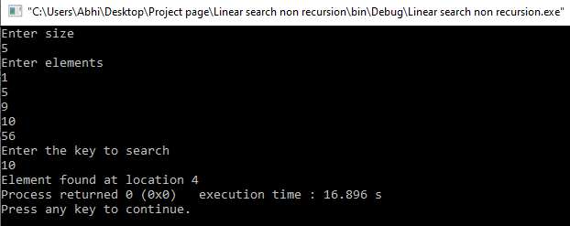

**TEST CASE 2:**

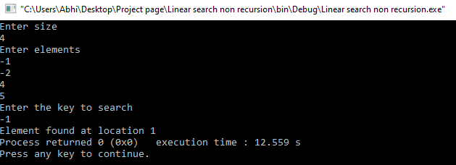

**TEST CASE 3:**

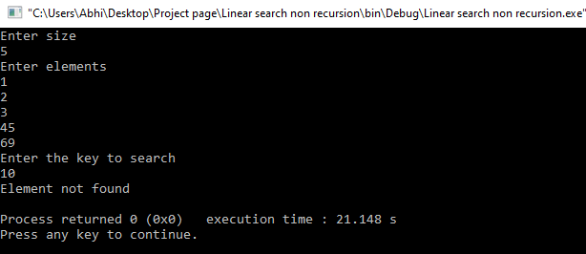

**LINEAR SEARCH USING RECURSION:**

#include <stdio.h>

int lsearch_recursion(int a[],int n,int key)

{

if(n<0)

return -1;

if(key==a[n-1])

return n-1;

lsearch_recursion(a,n-1,key);

}

int main()

{

int a[50],i,n,x,r;

printf("Enter size\n");

scanf("%d",&n);

printf("Enter the elements\n");

for(i=0;i<n;i++)

scanf("%d",&a[i]);

printf("Enter the key to search\n");

scanf("%d",&x);

r=lsearch_recursion(a,n,x);

if(r==-1)

printf("Unsuccessful search\n");

else

printf("Element found at %d",r);

}

**OUTPUT:**

**TEST CASE 1:**

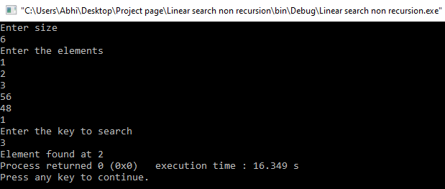

**TEST CASE2:**

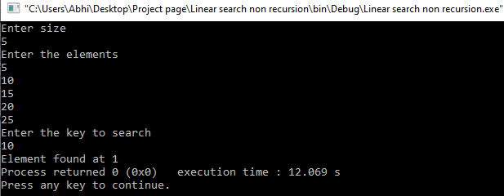

**TEST CASE 3:**

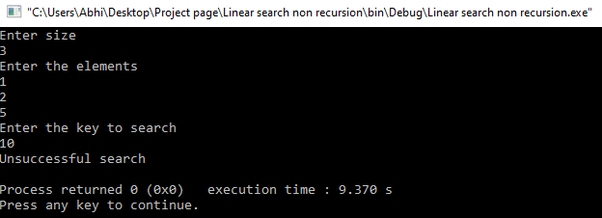

**BINARY SEARCH USING NON RECURSION:**

#include<stdio.h>

int bsearch(int a[],int n,int key)

{

int low=0;

int high=n-1;

int mid;

while(low<=high)

{

mid=(low+high)/2;

if(key==a[mid])

return mid;

else if(key<a[mid])

high=mid-1;

else

low=mid+1;

}

return -1;

}

int main()

{

int a[50],i,n,x,r;

printf("Enter size\n");

scanf("%d",&n);

printf("Enter the elements\n");

for(i=0;i<n;i++)

scanf("%d",&a[i]);

printf("Enter the key to search\n");

scanf("%d",&x);

r=bsearch(a,n,x);

if(r==-1)

printf("Unsuccessful search\n");

else

printf("Element found at %d",r);

}

**OUTPUT:**

**TEST CASE 1:**

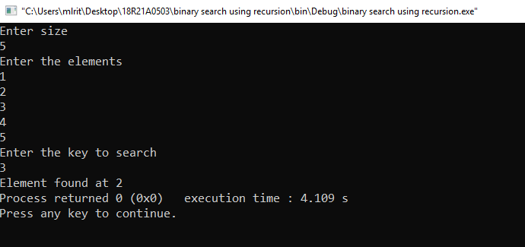

**TEST CASE 2:**

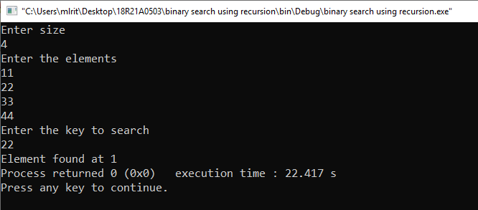

**TEST CASE 3:**

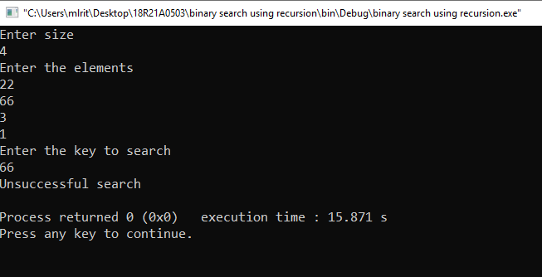

**BINARY SEARCH USING RECURSION:**

#include<stdio.h>

int binsearch(int a[],int x,int low,int high)

{

int mid;

if(low>high)

return -1;

mid=(low+high)/2;

if(x==a[mid])

return mid;

else if(x<a[mid])

binsearch(a,x,low,mid-1);

else

binsearch(a,x,mid+1,high);

}

int main()

{

int a[50],i,n,x,r;

printf("Enter size\n");

scanf("%d",&n);

printf("Enter the elements\n");

for(i=0;i<n;i++)

scanf("%d",&a[i]);

printf("Enter the key to search\n");

scanf("%d",&x);

r=binsearch(a,x,0,n);

if(r==-1)

printf("Unsuccessful search\n");

else

printf("Element found at %d",r);

}

**OUTPUT:**

**TEST CASE 1:**



**TEST CASE 2:**



**TEST CASE 3:**

